Developer Guide
jWebSocket
Python client library

Overview
The project's main objective is to increase the usability of the framework jWebSocket. To achieve this we implemented a client library that allows developers to Python programming language to develop applications using jWebSocket as an application server. They claim to create a library light but it meets all the expectations of developers.
- Infrastructure, Model, Approach
In general the solution has been designed to support two core layers constituting the two ways in which use can be given to the client library. Layer is created a high and a low level that meets specifications and WebSocket jWebsocket server respectively.
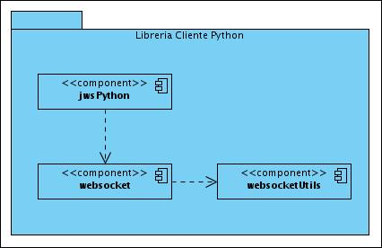
Figure 1: Diagram of components of the Python client library for jWebSocket.

In the diagram can be seen the two fundamental layers used to model the library. The component is named jwsPython high-level layer that functions as an abstraction for the WebSocket protocol following features and functionalities jWebsocket server. WebSocket component represents a low-level implementation specification of the W3C and the IETF for the WebSocket protocol in the Python programming language, using this component can communicate with any server that meets WebSocket the standards defined for the protocol. The component websocketUtils contains a set of classes and algorithms used to implement the protocol.
Within the design patterns used is the Observer pattern that allows subscribing to events related to connecting and sharing information.
Although the library is designed for use in client-server applications implemented all concerning this solution is based on client-side code. Bone is not implemented anything jWebSocket server to accept requests from the client Python if you deploy a client library used the Python programming language that meets the specifications proposed by the jWebsocket server.

Requierement and prerequisites
The prerequisites of this library are practically nil, as it only requires installation of Python on your computer.

Modules, Structures
All files that make up the library is located in the folder websocket_client as shown in the image below:
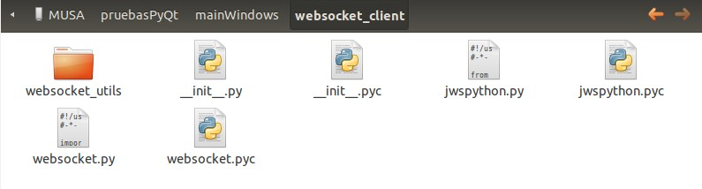
Figure 2: Root Folder.
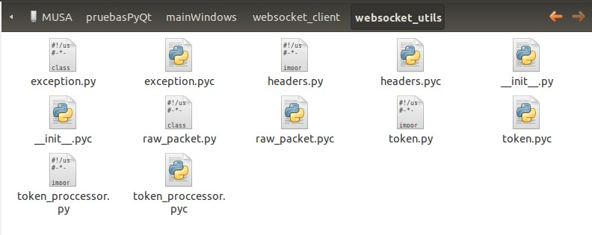
As shown in the image above into the root directory components are high-level and low level of the library that can be used by developers.
Figure3: websocket_utils.
Websocket_utils directory shown below are several classes and algorithms that are useful for the library in general. The following gives a brief explanation of the elements included in the module websocket_utils.
- Exeption: Custom exceptions defined for the library.
- Headers: Methods are defined with the algorithms necessary to convert an object of type WebsocketRawPacket a logical sequence of bytes to be sent as specified by the protocol outlined in the picture below.
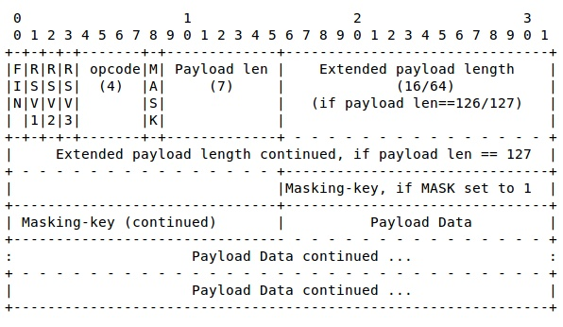

- WebsocketRawPacket: An object that contains the data and the specifications needed to build the package that meets the standard defined in the protocol WebSocket.
- Token: Object used as subprotocol form of communication or understanding with jWebSocket server. A token is only an object that has a namespace and a type of token as well as additional information from the application itself.
- token_proccessor: Contains the algorithms necessary to convert the token to JSON format to be sent when and to convert native Python objects once they are received.

Source Code

Component: websocket
class | WebSocket
Description | This class acts as a client that implements low-level native protocol specifications WebSocket.
Dependence | import uuid  import socket  import thread  import base64  import hashlib  import logging  from urlparse import urlparse  from websocket_utils import headers  from websocket_utils.exception import WebSocketException, ConnectionClosedException  from websocket_utils.raw_packet import WebsocketRawPacket
Properties | List of member variable of the class.
connected | Boolean: True or false depending on connection status.
on_text_message | Function: Reference to the callback function used as a listener when you receive a text message.
on_binary_message | Function: Reference to the callback function used as a listener when a message is received binary.
on_open | Function: Reference to the callback function used as a listener when you open the connection.
on_close | Function: Reference to the callback function used as a listener when you close the connection.
on_ping | Function: Reference to the callback function used as a listener when it receives a ping from the server.
on_pong | Function: Reference to the callback function used as a listener when receiving a pon from the server.
io_sock | Socket: Native TCP socket programming language Python on whereby the connection to the server.
Methods | List of methods
__init__ | Initializer and constructor of the class.
open | Method stable connection with sending the handshake.
close | Close the connection.
send_text | Send a text message to the server type.
send_binary | Send a message to the server binary.
send_text_maxframesize | Send a message in text dividing it by the maximum size parameter passed to the method.
send_binary_maxframesize | Send a message binary dividing it by the maximum size parameter passed to the method.
ping | Send a message to the server ping
pong | Used to respond to a ping sent by the server.
get_request_header | Returns a map with the header sent in the handshake.
get_response_header | Returns a map with the header returned by the server.
get_request_header_field | Returns the value of a given field belonging to the header sent by the client in the handshake.
get_response_header_field | Returns the value of a given field belonging to the header received in the handshake.

Component: jwsPython
class | JWSClient
Description | This class acts as a client that implements high-level specifications jWebSocket server.
Extends | WebSocket
Dependence | from websocket import WebSocket  from websocket_utils.token_proccessor import convert_to_dic_type  from websocket_utils.token_proccessor import dict_to_object
Methods | List of methods.
send_token_text | Send a token to the server in text format.
send_token_binary | Send a token to the server in binary format.
send_token_fragmented | Send a broken token to the server.
_convert_to_token | Converts a token object.

Component: websocketUtils
class | WebsocketRawPacket
Description | Represents a native package WebSocket protocol.
Properties | List of properties
byte_array | Are the bytes that make up the payload.  The payload is the specific information to be sent to the server.
m_is_end_frame | Determines if the package is final or is a fragment.
m_frame_type | Determines the packet type to be sent to the server. To better understand this must be seen in the protocol specifications the meaning of opcode.

Component: websocketUtils
class | Token
Description | Shaped object map used as a subprotocol of understanding between the server and client jWebSocket.
add_data | Adds a key attribute value
get_atribute | Returns the value of an attribute given its key
get_as_dic | Returns the token type object in dictionary form.

Component: websocketUtils
Exeptions | Exceptions listed class
WebSocketException | Exception to the highest level of heritage and common exceptions to the custom
ConnectionClosedException | Type exceptions WebSocketExeption extends connections.
TokenFormatException | Launched when formed or receives a malformed token.

